

**Aim:** Write a menu driven program that implement following operations on a linear array:

* Insert a new element at a specified position
* Delete an element either whose value is given or whose position is given
* To find the location of a given element
* To display the elements of the linear array

**Program Code:**

#include<iostream>

using namespace std;

class arr

{

int n,a[100];

public:

void particular(int b[], int &n, int size);

void deleteavalue(int b[], int &n, int size);

void search(int b[], int &n, int size);

void display(int b[],int &n,int size);

void deleteatpos(int b[],int &n,int size);

};

void arr::particular(int b[], int &n, int size)

{

if(n>size)

{

cout<<"overflow";

}

else

{

cout<<"enter the number and index number which you want to insert?";

int no=0, index=0;

cin>>no;

cin>>index;

for(int i=n;i>=index;i--)

{

b[i+1]=b[i];

}

b[index]=no;

n=n+1;

}

}

void arr::deleteavalue(int b[], int &n, int size)

{

int s;

cout<<"enter the no you want to delete.";

int no;

cin>>no;

for(int i=0;i<n;i++)

{

if(b[i]==no)

{

s=i;

break;

}

}

for(int i=s;i<n;i++)

{

b[i]=b[i+1];

}

n=n-1;

}

void arr::search(int b[], int &n, int size)

{

int item;

cout<<"enter the item to be searched:\n";

cin>>item;

int i;

int flag=0,loc=0;

for(i=0;i<=n;i++)

{

if(b[i]==item)

{

flag=1;

loc=i;

break;

}

}

if(flag==1)

cout<<" element found at index: "<<loc;

else

cout<<"not found";

}

void arr::display(int b[],int &n,int size)

{

for(int i=0;i<n;i++)

{

cout<<b[i]<<endl;

}

}

void arr::deleteatpos(int b[],int &n,int size)

{

int s;

cout<<"enter the position at which you want to delete.";

int pos;

cin>>pos;

for(int i=pos;i<=n;i++)

{

b[i]=b[i+1];

}

n=n-1;

}

int main()

{

arr ll;

cout<<"enter the size of array"<<endl;

int size;

cin>>size;

int a[size];

cout<<"how many elements you want to enter in an array?";

int n;

cin>>n;

for(int i=0;i<n;i++)

{

cin>>a[i];

}

cout<<"enter your choice "<<endl;

cout<<"1.Insertion at specified position"<<endl;

cout<<"2.Delete an element whose position is given"<<endl;

cout<<"3.Delete an element whose value is given"<<endl;

cout<<"4.find location of given element"<<endl;

cout<<"5.Display elements of a given array"<<endl;

int choice;

cin>>choice;

while(choice!=-1)

{

switch(choice)

{

case 1:

ll.particular(a,n,size);

break;

case 2:

ll.deleteatpos(a,n,size);

break;

case 3:

ll.deleteavalue(a,n,size);

break;

case 4:

ll.search(a,n,size);

break;

case 5:

ll.display(a,n,size);

break;

}

cin>>choice;

}

}

**OUTPUT:**

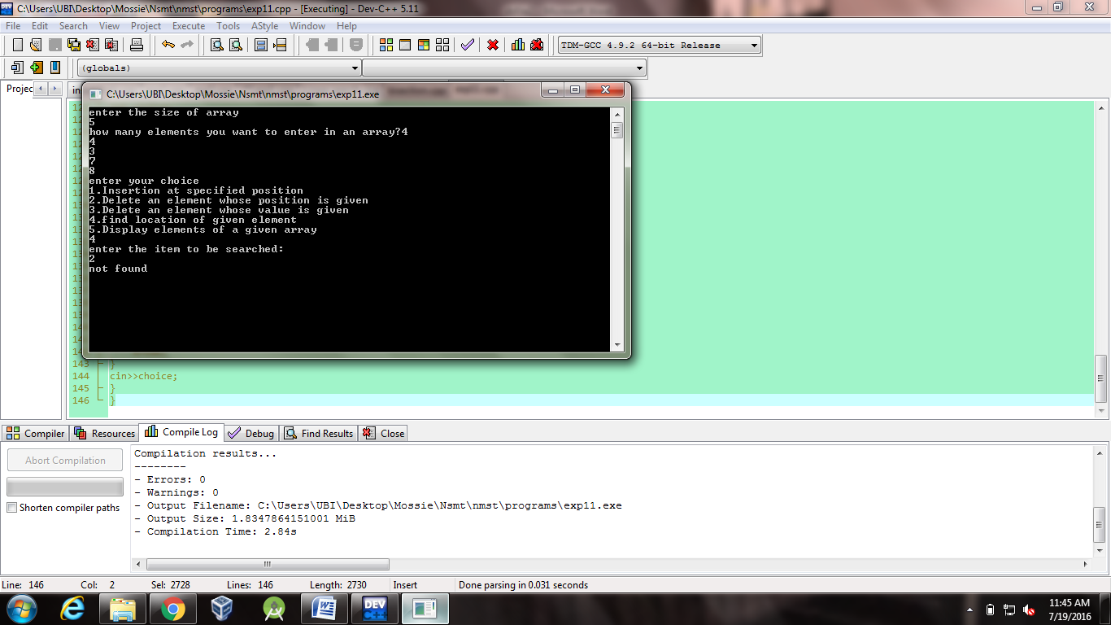



**Aim:** Write a program to accept N numbers from the user and store them in an array. Then, accept another number from the user and search that using Linear Search.

**Program Code:**

#include<iostream>

using namespace std;

class arr

{

public:

void create();

void display();

};

void arr::create()

{

int i,n,flag=0,j;

cout<<"enter the no. of elements in an array"<<endl;

cin>>j;

int a[j];

cout<<"enter the "<<j<<" elements"<<endl;

for(i=0;i<j;i++)

{

cin>>a[i];

}

}

void arr::display()

{

int flag=0,n,i,j,a[100];

cout<<"enter no. to be checked"<<endl;

cin>>n;

for(i=0;i<j;i++)

{

if(a[i]==n)

{

flag=1;

cout<<"index of no. is "<<i<<endl;

break;

}

else{

flag=0;

}

}

if(flag==1)

{

cout<<"YES no. is present";

}

else

{

cout<<"NO no. is not present";

}

}

int main()

{

arr ll;

ll.create();

ll.display();

}

**OUTPUT:**

